Price of Mangoes

DESCRIPTION:
There's a "3 for 2" (or "2+1" if you like) offer on mangoes. For a given quantity and price (per mango), calculate the total cost of the mangoes.

SOLUTION:
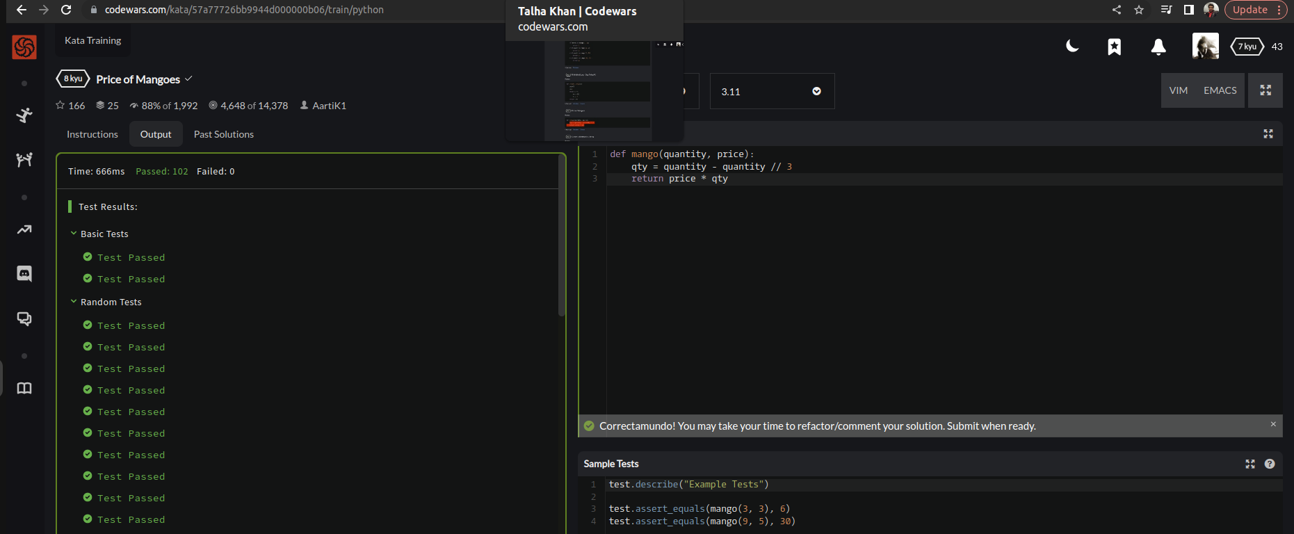

EXPLANATION:
So we’re asked to calculate the total cost of mangoes. So therefore, to calculate a total cost we first need to declare a variable named qty as quantity in which we need to minus the parameter of quantity by itself by and we’ll divide by 3 to find a given quantity and price (per mango) returning them in function.

